React Blog website guide

================= Creating React app =============

Cmd-> npx create-react-app <app_name>

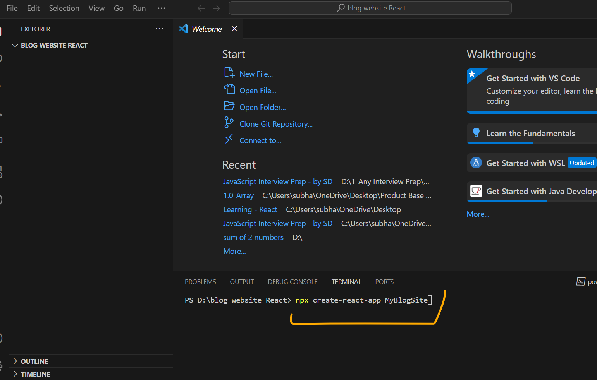

Once done, check it works or not

Go inside the directory

Cmd-> cd myblogsite

Cmd -> npm start

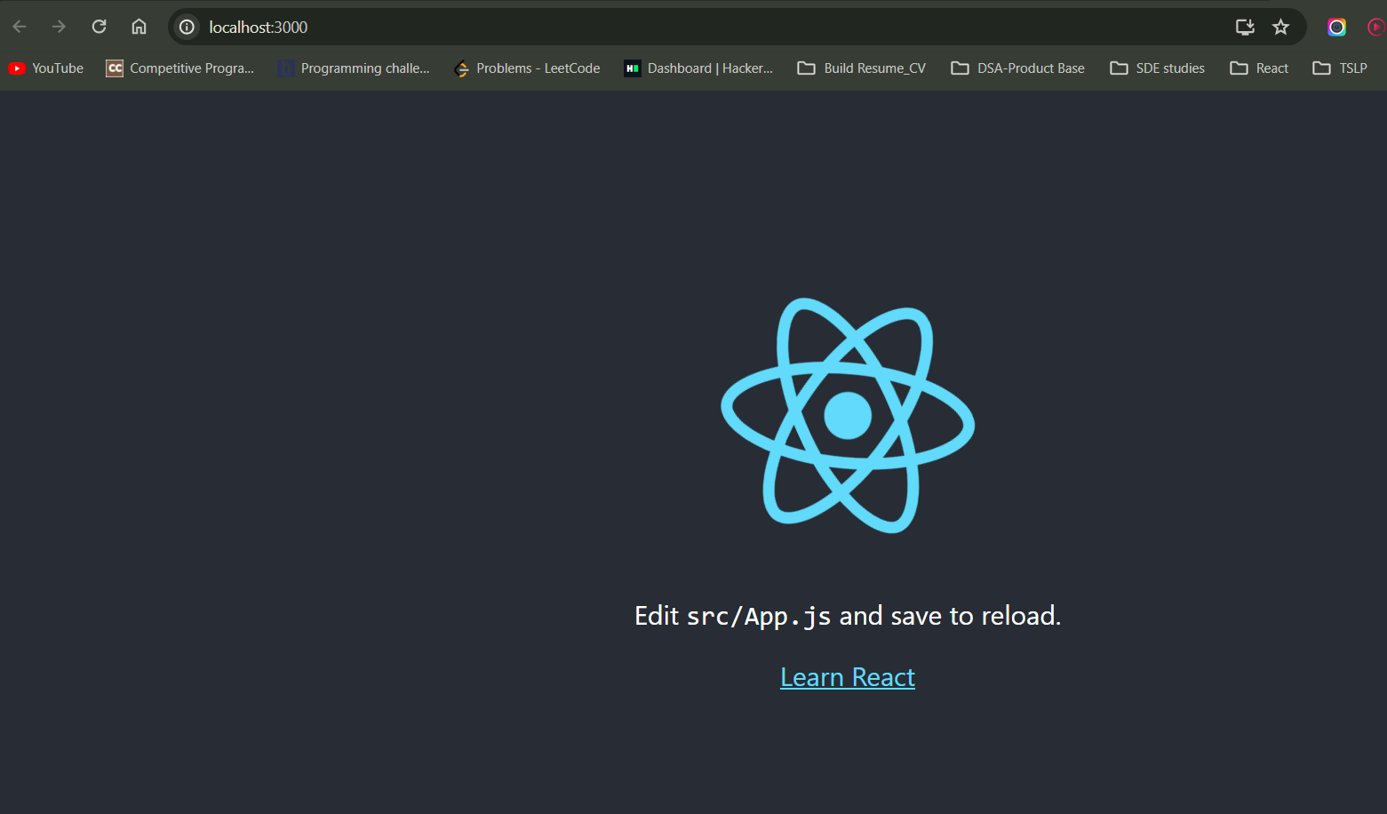

================= end=============

==============Remove some unnecessary files========

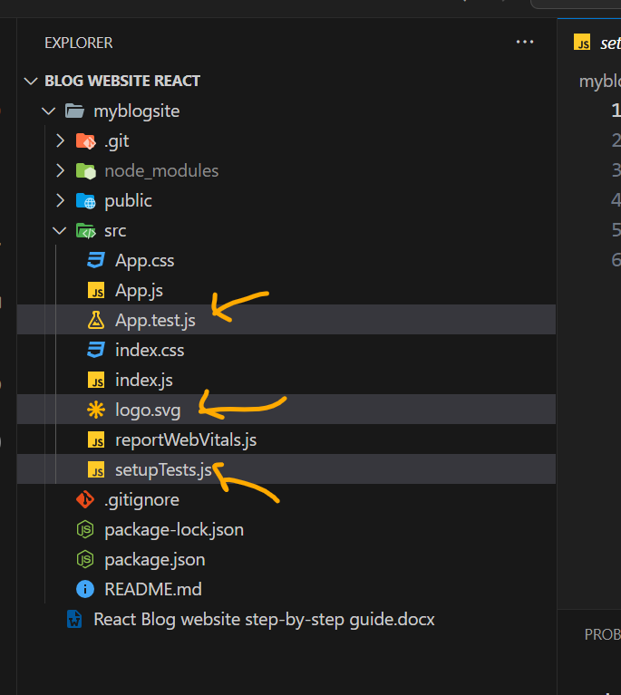

Cleaning app.js

Remove imported files

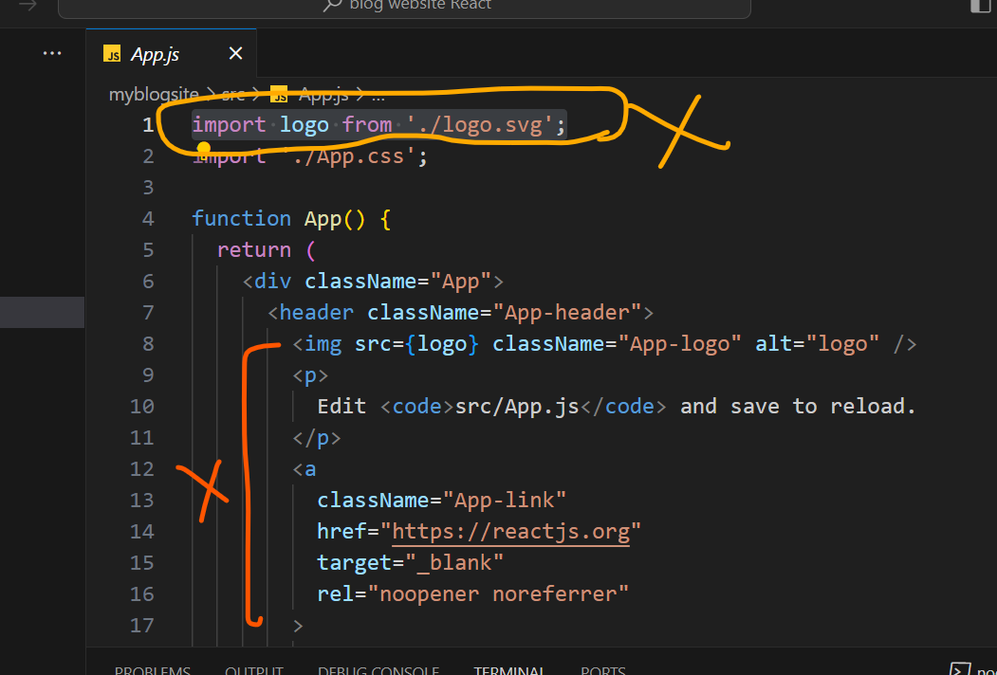

After Cleaning

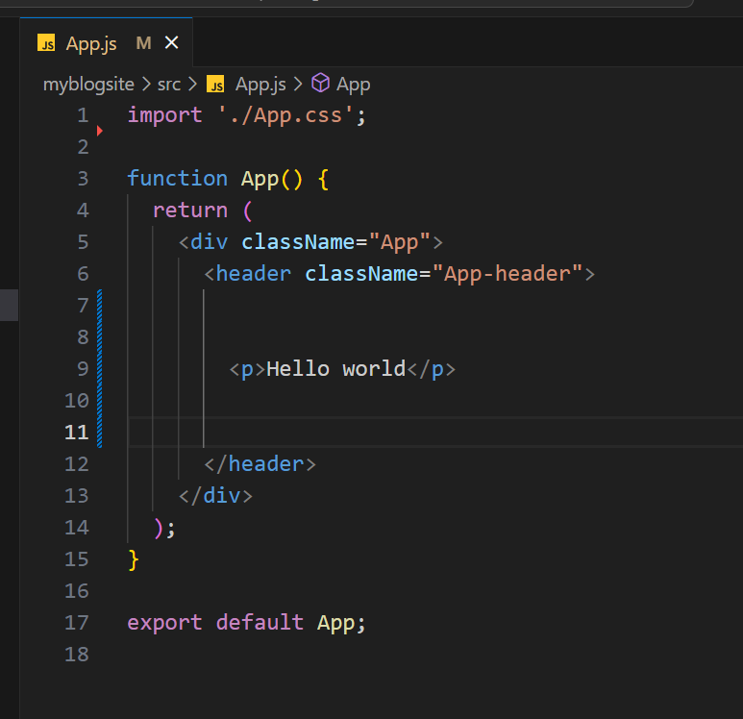

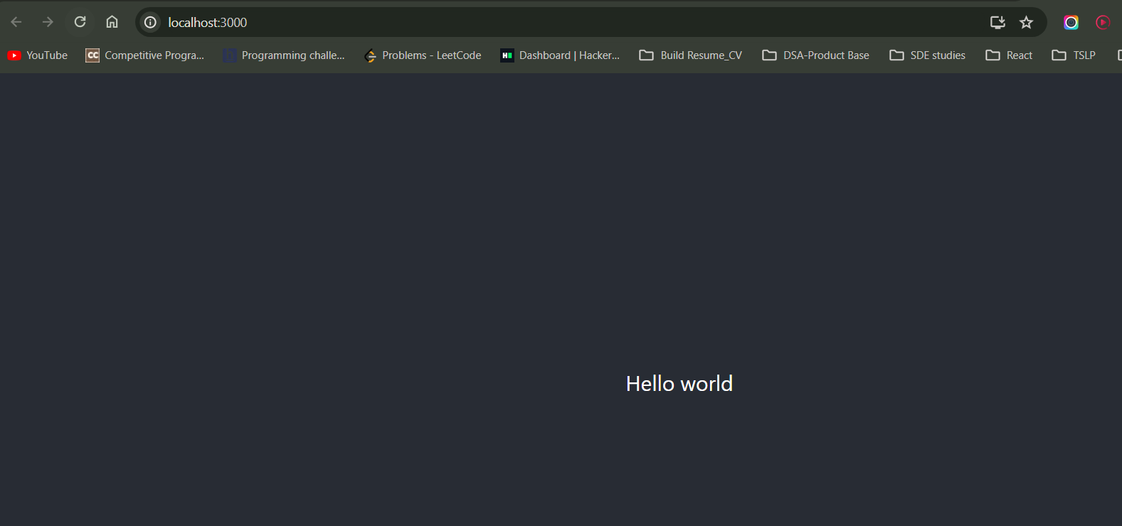

=====================end====================